Pancakes
Ingredients
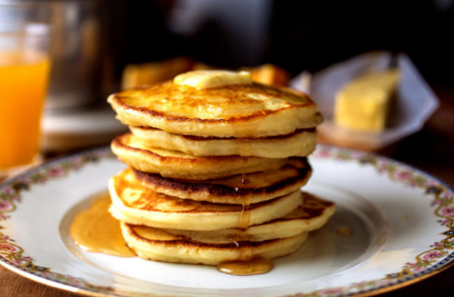
- 2 cups all-purpose flour
- 2 teaspoons baking powder
- ¼ teaspoon salt
- 1 tablespoon sugar
- 2 eggs
- 1 ½ to 2 cups milk
- 2 tablespoons melted and cooled butter (optional), plus unmelted butter for cooking, or use neutral oil
Preparation
- Heat a griddle or large skillet over medium-low heat.
- In a bowl, mix together dry ingredients.
- Beat eggs into 1 1/2 cups milk, then stir in 2 tablespoons melted cooled butter (optional). Gently stir this mixture into dry ingredients, mixing only enough to moisten flour (a few lumps are okay). If batter seems thick, add a little more milk.
- Place a teaspoon or two of butter or oil on griddle or skillet. When butter foam subsides or oil shimmers, ladle batter onto griddle or skillet, making pancakes of any size you like. Adjust heat as necessary; usually, first batch will require higher heat than subsequent batches.
- Flip pancakes after bubbles rise to surface and bottoms brown, after 2 to 4 minutes.
- Cook until second side is lightly browned. Serve, or hold on an ovenproof plate in a 200-degree oven for up to 15 minutes.
- Decorate the pancake with toppings (optional).
Ideas for toppings: chocolate chips, banana, peanut butter, Nutella, strawberries, blueberries, nuts, maple syrup, honey, yogurt, butter
Pancake recipe adapted from https://cooking.nytimes.com/recipes/1893-everyday-pancakes

